**Remote Sensing IoT Based Obstacle Avoider Robot**

**Solaiman Hossain Tuhin**

**Student ID: 173-15-1639**

**AND**

**Md. Khalid Bin Hasan Sarker**

**Student ID: 181-15-1789**

**AND**

**Md. Masbahul Islam Shaik**

**Student ID: 181-15-1773**

This Report Presented in Partial Fulfillment of the Requirements for the

Degree of Bachelor of Science in Computer Science and Engineering

Supervised By

**Tajim Md. Niamat Ullah Akhund**

Lecturer

Department of CSE

Daffodil International University

Co-Supervised By

**Zakia Sultana**

Lecturer

Department of CSE

Daffodil International university



**DAFFODIL INTERNATIONAL UNIVERSITY**

**Dhaka, Bangladesh**

**OCtober 2021**

**APPROVAL**

The Project titled “**IoT based Obstacle Avoider Robot**”, submitted by Solaiman Hossain Tuhin, ID: 173-15-1639, Md. Khalid Bin Hasan Sarker, ID: 181-15-1789, Md. Masbahul Islam Shaik, ID: 181-15-1773 to the Department of Computer Science and Engineering, Daffodil International University, has been accepted as satisfactory for the partial fulfillment of the requirements for the degree of B.Sc. in Computer Science and Engineering and approved as to its style and contents. The presentation has been held on 30-10-2021.

**Board of Examiners**



**Dr. S. M. Aminul Haque Internal Examiner**

**Associate Professor**

Department of CSE

Faculty of Science & Information Technology

Daffodil International University



**Narayan Ranjan Chakraborty**

**Assistant Professor Internal Examiner**

Department of CSE

Faculty of Science & Information Technology

Daffodil International University

**External Examiner**

**Declaration**

We hereby declare that, this project has been done by us under the supervision of **Tajim Md. Niamat Ullah Akhund, Lecturer, Department of CSE** Daffodil International University. We also declare that neither this project nor any part of this project has been submitted elsewhere for award of any degree or diploma.

**Supervised by:**



**Tajim Md. Niamat Ullah Akhund**

Lecturer

Department of CSE

Daffodil International University

**Co-Supervised by:**



**Zakia Sultana**

Lecturer

Department of CSE

Daffodil International University

**Submitted by:**



**(Solaiman Hossain Tuhin)**

ID: 173-15-1639

Department of CSE

Daffodil International University



**(Md. Khalid Bin Hasan Sarker)**

ID: -181-15-1789

Department of CSE

Daffodil International University



**(Md. Masbahul Islam Shaik)**

ID: -181-15-1773

Department of CSE

Daffodil International University

**ACKNOWLEDGEMENT**

First, we express our heartiest thanks and gratefulness to almighty God for His divine blessing makes us possible to complete the final year project successfully.

We really grateful and wish our profound our indebtedness to **Tajim Md. Niamat Ullah Akhund**, **Lecturer**, Department of CSE Daffodil International University, Dhaka. Deep Knowledge & keen interest of our supervisor in the field of “*Internet of Things, Machine Learning & Robotics*” to carry out this project. His endless patience, scholarly guidance, continual encouragement, constant and energetic supervision, constructive criticism, valuable advice, reading many inferior drafts and correcting them at all stage have made it possible to complete this project.

We would like to express our heartiest gratitude to Tajim Md. Niamat Ullah Akhund, Zakia Sultana and Head, Department of CSE, for his kind help to finish our project and also to other faculty member and the staff of CSE department of Daffodil International University.

We would like to thank our entire course mate in Daffodil international University, who took part in this discuss while completing the course work.

Finally, we must acknowledge with due respect the constant support and patients of our parents.

**ABSTRACT**

Obstacle avoidance is an important task in robotics as the independent robotics’ intention is to attain the vacation spot without collision. One kind of self-reliant robotic that may stumble on obstacles and edges and take possible paths freed from boundaries and edges is a real-time obstacle-avoiding detection robot. This paper proposes a robotic with intelligence constructed into it that guides itself every time an obstacle comes along its way by using the usage of an algorithm set of policies. This robotic is constructed the usage of Arduino Uno. Any obstacle with edges is detected by the ultrasonic sensor, which transmits an instruction to the Arduino. The micro-controller, based completely on the received input signal, guides the robotic to push in an alternative way via actuating the vehicles that are interfaced with it via a motor deliver force. Depending on the situation the robot is capable of picking the best route. This robot also can sense data by other sensors and fetch the data from there to cloud storage. There anyone can see real-time data on a PC or mobile. This robot became designed to consider its daily potentialities. Being a completely self-sufficient robotic, it correctly maneuvered in unknown environments with no collision. cheaper which makes the robotic effortlessly replicable.

**Keyword:** Motor Driver L298n, Ultrasonic or Echo Sensor HC-SR04, DC Motor, Servo Motor, Node MCU, DHT11 Temperature & Humidity sensor, Arduino UNO.

**TABLE OF CONTENTS**

|  |  |
| --- | --- |
| **CONTENTS** | **PAGE** |
| Board of examiners | i |
| Declaration | ii |
| Acknowledgement | iv |
| Abstract | v |
| **CHAPTER** |  |
| **CHAPTER 1: Introduction 1-4** |  |
| * 1. Introduction 1   2. Motivation 1   3. Objective 2   4. Feature 2   5. Expected Outcome 2   6. Problem Statement 3   7. Social Impact 3   8. Report Layout 4   **CHAPTER 2: Literature Review 5-13**  **CHAPTER 3: Requirement Analysis and Methodology 14-32**  3.1 Requirement Analysis 14  3.1.1 Arduino Uno 14  3.1.2 Breadboard 15  3.1.3 Jumper Wire 16 3.1.4 DHT 11 Sensor 17  3.1.5 Node MCU 18  3.1.6 LiPo Battery 20  3.1.7 Ultra Sonic Sensor 21  3.1.8 Motor Driver 22  3.1.9 Soldering Iron 23  3.1.10 Screwdriver 23  3.1.11 Servo Motor 24  3.1.12 Arduino Mega USB 25  3.1.13 Two DC Motor 25  3.1.14 Robotics Chassis 26  3.1.15 Ultra Sonic Sensor Mounting Bracket 27  3.1.16 Hot Glue Gun 28  3.2 Methodology 30  3.2.1 System Architecture 30  3.2.2 Flow Chart 31  3.2.3 Algorithm 32  **CHAPTER 4: Result 33-41**  4.1 Project Implementation 33  4.2 Result Discussion 40  4.3 Feature Analysis 41  4.4 Limitation 41  **CHAPTER 5: Future works and Conclusions 42**  5.1 Future works 42  5.2 Conclusions 42  **REFERENCES 43-46** |  |
|  |  |

**LIST OF FIGURES**

|  |  |
| --- | --- |
| **FIGURES** | **PAGE NO** |
| Fig: 1.1 Report Layout | 4 |
| Fig: 3.1.1: Arduino Uno | 14 |
| Fig: 3.1.2: Breadboard | 16 |
| Fig: 3.1.3: Jumper Wire | 17 |
| Fig: 3.1.4: DHT11 Temperature and Humidity sensor Module | 18 |
| Fig: 3.1.5: Node MCU | 19 |
| Fig: 3.1.6: LiPo Battery | 20 |
| Fig: 3.1.7: Ultrasonic sensor | 21 |
| Fig: 3.1.8: L298n Motor driver | 22 |
| Fig: 3.1.9: Soldering Iron | 23 |
| Fig: 3.1.10 Screwdriver | 24 |
| Fig: 3.1.11: Servo Motor SG90 | 24 |
| Fig: 3.1.12: Arduino Mega USB | 25 |
| Fig: 3.1.13: Two DC Motors | 26 |
| Fig: 3.1.14: Two Wheel Robot Car Chassis | 27 |
| Fig: 3.1.15: Ultrasonic Sonar Sensor Mounting Bracket | 28 |
| Fig: 3.1.16 Hot Glue Gun | 29 |
| Fig: 3.2.1: System Architecture | 30 |
| Fig: 4.1.1 Project Top View | 33 |
| Fig: 4.1.2 Project Rear View | 34 |
| Fig: 4.1.3 Project Side View | 35 |
| Fig: 4.1.4 Project Front View | 36 |
| Fig: 4.1.5 Cloud Server | 37 |
| Fig: 4.1.6 Cloud Server | 38 |
| Fig: 4.2.2: Graphical representation | 40 |

**LIST OF TABLES**

|  |  |
| --- | --- |
| **TABLES** | **PAGE NO** |
| Table: 4.2.1 Accuracy Result Table | 39 |

**CHAPTER 1**

**Introduction**

**1.1 Introduction**

A method for avoiding major obstacles This robot is designed for you if you want to navigate the robot in unknown places while avoiding collisions. Obstacle-avoiding robot detects limitations inside the course, avoids it, and resumes moving. When an ultrasonic sensor detects an obstruction ahead of time, it sends an instruction to the Arduino. This challenge will produce a robot that will follow the directions and may visit a mysterious location to collect data and assist people. It will approach the practice through Arduino and bypass the robotic through the way of following the instructions inside the algorithm. Wherever our robotic goes it will experience temperature and humidity datasets. It will gather data there and send it to a cloud database through Wi-Fi and the internet. The detection results are also influenced by the weather, and the DHT11 sensor's sensing reliability reduces as moisture and humidity levels rise. We created a low-cost robot based on obstacle avoidance in our equipment. According to the algorithm's instructions, the robot will move forward, backward, left, and right. This technique could be beneficial for a variety of reasons. We've also included a basic set of rules and a layout that can be enhanced based on the programs specified.

**1.2 Motivation**

The concept of a self-reliant robot isn't always a new one. Every corporation that uses robots to carry out tasks would love the robot in order to carry out its capabilities efficiently with no outside manipulate. The ability to keep away from barriers routinely is a crucial part of sensible robot cars and creates a safety warranty for destiny travel. Obstacle Avoidance is the bottom, or zeroth, level of competence, meaning it's miles the center functionality of a self-sufficient robot device upon which the whole thing else depends. If an autonomous robotic may be made to avoid entering contact with objects inside the surroundings, then different higher-degree competencies can accurately be incorporated into the machine. An ultrasonic sensor would be the maximum suitable for obstacle detection. It turned into hard to build any such robot as it has interfacing and integration of many components. The concept at the back of this changed into an easy remote sensing bot, in which the bot detects an obstacle and changes its path. Eventually, we've made this mission to make people's lifestyles simpler.

**1.3 Objective**

1. It can visit a faraway and obscure place in which man can't go.
2. This robot easily collects information from unknown environment & stored it in cloud.

**1.4 Feature**

1. It can detect obstacle and avoid it in.
2. After detecting obstacle by sonar sensor, we can also detect the freeways.
3. It can detect the freeways in 3 directions continuously by using servo motor.
4. It also can detect temperature and humidity by DHT11 sensor.
5. It can store the data in cloud by using Node MCU.
6. It can go where man cannot go to earn some information.
7. Using cloud server anyone can analyze the data remotely.
8. It can use in many dangerous missions.
   1. **Expected Outcome**
9. The issues of real time temperature monitoring will be solved in no man's land areas.
10. It can go there where people's life is risky & we can reduce people death rate.
11. Everything in that area is easy to track and monitor.
12. Anybody or any industrial company can afford this robot easily.

**1.6 Problem Statement**

An essential call for of companion degree self-reliant mechanism is obstacle avoiding. This obstacle avoidance performance is of high-quality importance inside the navigation system of a robot in an unknown area with a view to keep it away from conflict during its task. It is essential for an independent robot to avoid it so one can avoid destructive the item or the robot itself. Even in robots that upload a well-recognized putting and consequently the robotic path has been set efficaciously, environmental modifications can arise that cause the mechanism to hit an object, that the robotic should be able to navigate itself adapt to modify through avoiding any object in its route. This disadvantage of cost-effective direction arising with is what has crystal rectifier to the need for a robotic which could find out and avoid gadgets in the course of a precomputed direction or items that appear. The answer to the existing course hassle involves the usage of sensors by the robot to hit upon objects and avoid them, consequently developing the robotic extra freelance since it may not want outside influences.

**1.7 Social Impact**

The robotic can serve the society. It can gather information from faraway place. And also, can gather information from nature. The objective to make this robot is to obstacle avoiding & sensing the temperature in temperature sensitive areas such as in a cold storage or a food reserve or chemical industries etc. Usually, the storage areas are very large and it is almost impossible for people to monitor the temperature manually. Then we can use our robot in this work. Another option for doing this particular job is to set some permanent temperature sensors on some places. But implementation of this technique is not cost effective and maintenance is also very difficult for poor countries like Bangladesh. This robot is capable of detecting temperatures in almost all the areas of a cold storage and maintaining this robot is very easy and it is also cost efficient than other complex temperature monitoring systems. This may have a first-rate tremendous effect on our society.

**1.8 Report Layout**

Report layout: The project's visual presentation is comprised of a figure that clearly depicts the whole endeavor. The material, as well as additional information the material, and so much more. The project report is divided into 5 chapters. All chapters are explained in detail by a demographic depiction, which includes a short description.

|  |
| --- |
| **Chapter 1: INTRODUCTION**  Concerning this project, Motivations, Objectives, Features, Social Impact, Problem Statement. |

|  |
| --- |
| **Chapter 2: LITERATURE REVIEW**  Review previous work |

|  |
| --- |
| **Chapter 3: REQUIREMENT ANALYSIS AND METHOLOGY**  Equipment analysis, System Methodology, Algorithm |

|  |
| --- |
| **Chapter 4: RESULTS AND OUTPUT**  Implement Methodology, Show the Output |

|  |
| --- |
| **Chapter 5: CONCLUSSION**  Conclusion, Future Plan, Reference |

Fig.1.1 Report Layout

**CHAPTER 2**

**Literature Review**

The author of [1] This paper tested the most recent advances within the improvement of self-sufficient IoT drone structures managed by means of deciliter strategies. The article gave in-depth research into the state of the art of deciliter approaches for self-sufficient obstacle detection and avoidance by assessing the challenges that arise when drones are expected to discover and avoid constraints. Furthermore, the most relevant datasets and, as a result, DLUAV algorithms pay attention to the hardware element. With regard to this material, the most current and updated DLUAV communication architectures have been described, with particular attention to the various subsystems of the architecture and therefore to the training developments brought by the DLUAV systems. Finally, the open challenges most relevant to current DLUAVs are listed, establishing a transparent roadmap for future DLUAV developers who can produce the next generation of autonomous and efficient DLUAV solutions for IoT drones.

The author of [2] There are a variety of cellular robot concepts and implementations that may be advanced, updated, and updated on a regular basis. Updates in development on available structures. Sensors, as well as LM35 and Arduino with sonar and a number of sensors, are utilized to stumble upon the chimney. The larva is in one of the structures, and in any other variant, the customer commands the robot via Bluetooth. The robotic application communicates with the Bluetooth module through a manual.

Positive collision avoidance systems built into all cellular robots, starting from basic algorithms that detect an object and stop the robot from heading off it to avoid a collision to advanced algorithms that allow the robotic to perform this operation during this project.

The author of [3] The LDR receives the maximum of sun so its resistance goes to its minimum value, LDR therefore its resistance goes to its maximum value, ideally infinite. artificial intelligence is that branch of technology that deals with the application of automata. the computer is described as a robot. The robot's navigation problems are usually the atmosphere around the robot. robot project considers international shipping. Collision avoidance systems are built into all mobile robots, ranging from simple algorithms that find an obstacle and stop the robot before avoiding it to exquisite algorithms that allow the robot to perform this operation during this project.

The author of [4] Associate Line Follower Analyzing Obstacles Avoiding Larvae Abuse Aamir Attar, Aadil Ansari, Abhishek Desai, Shahid Khan, and others designed and developed Arduino. Dipa Shrisona wale to create an independent mechanism that indicates intelligence to detect the obstacle in its route and navigate constant with the movements that the user has described for it. As a result, this device provides an alternative to the present machine of formal shifts with robot machines, which might therefore treat multiple patients in less time with greater precision and at a better cost per capita.

The author of [5] Aniket D. Adhvaryu et al. designed and built obstacle avoidance robots using IR and PIR motion sensors. This can be used for educational purposes, research, or commercial purposes. Students also use it to alert the programming microcontroller of potentially risky C++ processing, the Arduino Uno 1.6.5 IDE, the features of the IR and PIR sensing components, the motor drive circuit, and the device gate fashion. Situations utilizing signs. PLC analysis at the technical faculty level will make it easier for university students to improve their communications, technical abilities, and teamwork. The look of this type of robot is quite variable and varied in the manner in which it is frequently created to reserve for future use. When the police paint on a person, this indicates that PIR sensors are far more sensitive than IR sensors.

The author of [6] Turn away from the obstacle Vaghela et al. created and developed a Robotic Vehicle that uses an unsounded Sensor, Android, and Bluetooth for Obstacle Detection. Al stated that a significant level of work has went into the robot's main wi-fi gesture. One-of-a-kind methodologies are analyzed and reviewed with their merits and drawbacks inside the framework of numerous operational and centered strategies. As a result, it will be concluded that choices such as the telephone-based robot working machine's easy interface, lightweight, and mobility have passed the sophistication of technologies such as programmable gloves, static cameras, and so on, making them obsolete. Despite the fact that current research has made the dominating wi-fi gesture a widespread phenomenon, it is generating a lot of interest in related utility areas such as gadgets, wheelchairs, synthetic nurses, nursing devices, computer displays, and many more. In a really collaborative manner

The author of [7] Turning away from the obstacle Quan Chow dynasty stated that golem was devised and developed by Paul Kinsky, and that this robot with mechanical elements has two additional purposes to the most body, namely a laptop computer holder and a camera holder. The AT89S52 development board is conceived, developed, and tested on a large scale, which has become accustomed to smoothly managing motors. Machine vision calibration is performed using comparatively inexpensive cameras that are permanently linked and adjusted to the camera mount. Users set up serial communication between the higher laptop and the lower development board using a USB port. An engine standing signal can be sent from the laptop to the event board.

The author of [8] The obstacle avoidance car became designed and advanced through Faiza Tabassum, et. Al claimed that the impediment turning away vehicles with fulfillment detects and avoids boundaries. In end, the group managed to interface with each detail at the beginning plan. Timer interrupts to give you IR pulses. Obstacle detection thru IR transceiver. Servo mechanism thru PWM. Driving gadget through plaything and Servo.

The author of [9] The goal of this paper is to style a robotic vehicle that's ready to showing intelligence sight obstacle on its path associated avoid it. This was implemented by using supersonic and proximity sensors to detect obstructions, a motor driver to operate the DC motors, and a DC motor to move the robot with the help of an Arduino Microcontroller. The Arduino processing platform and its package counterpart written in the C programming language made it possible to communicate with the robot and deliver parameters for guiding movement. The result given an correct and economical detection of obstacles and its maneuvering so as to help vehicle driving. Obstacle turning away may be a superb application to be utilized in vehicle to forestall accidents and loss of life.

The author of [10] All throughout paper, the MSRBOTS is created for coalpit seek-and-rescue, and it is made up of two explosion-proof and water-resistant mobile robots, as well as an OCU. We have a tendency to state the mechanism, electrical device, and experiments all at the same time. MSRBOTS's results have also been added to supported assessments and experiments. Its walking ability, obstacle-clearing ability, and persistence ability are all better than the bulk of other robots, and its total performance is the best. It has also been approved with the assistance of the Safety Approval and Certification Center. The MSRBOTS has confirmed that it is effective after multiple testing.

The author of [11] Sensors used with digital gadgets were used in this record Sensors are gadgets that act as a bridge between the environment and several hundred types of sensors produced via the development of technologies together with warmness, strain, recognition of barriers, way to era within the subject of electronics, pretty The idea of the environment as a way to be crucial for the design of a robot is one of the most important parts of the robotics is one of the most important parts of the robotics is one of the most important parts of the robotics is the notion of the environment as a way to be crucial for the design of a robot. Pick explosives from a robot to use sensors to detect a terrorist in the army. In this book, a remote-controlled and self-contained robotic automobile is described in terms of obstacle recognition and avoidance with the use of sensors. Modes for controlling the robotic vehicle using an Android application the human and automatic control modes are as follows: On the screen is a menu with buttons for these buttons. These buttons may be used to move the robot forward, backward, left, and right, as well as stop it from entering into automated mode. When the consumer leaves the robotic in control, the robot discovers its own path without striking any obstacles. 2 Robotics Autonomous and remote sensing robot automobiles with real-time obstacle recognition and avoidance built entirely on Arduino the robot navigates its path without colliding with the factor or the sensor, and a scarlet led on it serves as a warning. Importance in real-time. Detecting and Avoiding Temporal Obstacles Using Arduino Section three describes robotic car running standards and gadget architecture.

The author of [12] For the challenge of obstacle avoidance in robot manipulators, a fuzzy-based navigation has been developed. The proposed navigation differs from existing impediment avoidance algorithms in that it considers the simplest the closest barrier to determine. This effectively leads to a large discount within the facts about the manipulator's surroundings, resulting in a multiplied possibility of avoiding the boundaries, which our navigator will not be capable of. Global techniques keep track of the entire workspace at each generation and compute the most effective obstacle avoiding path to the goal. Different obstacle configurations, both static and dynamic, provide a collision-free pathway for the robotic manipulator at all times. These algorithms perform well in simple workplaces; however, the cost of calculating global trajectories in densely populated areas is expensive. The suggested fuzzy navigator is a real-time neighborhood strategy that provides the device with a collision-free trajectory. Local minima are a problem that should not be missed. The gadget is offered by the one's impediment constellations, which lead to adjacent minima.

The author of [13] in this paper the purpose of the article was to gift a comprehensive review of the various ways of collision shunning and period of time route coming up with for ships, with a stress on the remote sensing of the radiolocation and also the use of different sensors for detection and tracking. target vessels. The analysis known several promising approaches within the recent literature. The analysis of many recent algorithms for collision avoidance and real-time route planning for ships has created it attainable to state that among the foremost vital characteristics the tactic ought to satisfy are: compliance of COLREG solutions, the just about real execution time, the dependableness of the computer file and also the repeatability of the results for every execution of calculations with an equivalent input data. The study also created it attainable to outline future directions of analysis, adore the matter of merging data from a radiolocation system with ARPA and AIS, and the ought to validate ways in field experiments, as an instance with the utilization of USV. The analysis of recent journal articles in the field into consideration allowed U.S. to perceive, that Associate in Nursing investigation of the ways of survey of ships in terms of their application within the SA module of YEARS for MASS might represent a awfully valuable contribution. Such an analysis ought to target deep learning methods, that seem to be very hip and give promising leads to the appliance for the vessel detection activity.

The author of [14] Cardinal The goal of this research is to build a robot that can function in a variety of modes, such as obstacle avoidance and line following, and might be used to detect gasoline line leaking. Looking at the results, it appears that the robots can successfully send information about gas line leaks that happened in its immediate environs to the wireless module, which can then display the results on the LCD display. Because of its dual-running capacity, the robot can be employed in a variety of remote locations to collect and transmit data concerning smoke or fuel line leaking. Curves have been given the use of smoke and LPG gas line formulae in that piece of art. Concentrations of the aforementioned gases have primarily been measured using Rs/Ro calculations derived from the aforementioned curves. The above-mentioned formulae for calculating the ppm of the gasoline line will be implemented into the microcontroller in the future so that the receiving module may mechanically calculate the ppm of the particular gas line.

The author of [15] This work proposes the OABAS set of rules, which is a single set of rules for determining direction decisions. A brand-new UAV direction planner has been presented as part of the BAS strategy. The MTS has been combined in this research to create a design that is both green and stable. We've applied this set of clever direction planning rules to UAV simulations. Has demonstrated the accepted applicability of OABAS set of rules impediment avoidance and as compared it with can elegantly layout a powerful and speedy direction planner through leveraging the proposed OABAS set of rules.

The author of [16] This research has offered a critical assessment of the status of the newest achievements within the field of self-sufficient vehicles from the viewpoints of sensor fusion, computer vision, machine identification, and fault tolerance. Sensible troubles and technical demanding situations related to the improvement of such tactics as they relate to self-sufficient automobiles. Autonomous automobiles have many capability packages and the call for them is In fact, self-sufficient automobiles are already being utilized in a few navy operations which include sensor fusion estimation method regularly relies upon the sort of hassle that exists in estimation techniques that had been used for sensor fusion had been primarily based totally at the manipulate idea and Many self-sufficient structures use cameras as the principle methodological method on the subject of self-sufficient automobiles in a number of specific Future making plans to enhance the location information for the multi-wheeled fight automobile through evolved a hybrid positioning method for GPS/INS Kalman clear out the use of each loosely Undeniably, improved numbers of sensors can result in a few faults taking place because of Thus, fault tolerance controls may be utilized so as to reap extra dependable manipulates reason is to save you easy faults from growing into extreme failure; thus, Additionally, in step with the machine identity studies literature, machine identity is a treasured technique for higher dependable self-sufficient automobiles may be designed withinside the destiny as soon as a higher expertise of With more secure and extra dependable self-sufficient automobiles in use, Future aims include developing a machine identity model for a multi-wheeled combat vehicle by determining the relationship between specific manipulation techniques and improving the vehicle's performance.

The author of [17] This work provides a dynamic collision shunning approach with advanced pricing boundaries, as well as a solution to the time collision avoidance problem under dynamic obstacle placement. This strategy is stepped forward in response to the current problem of pace hindrance technique. We tend to create a collision hazard analysis model and combine it with the discriminant circumstances of speed impediment, as required by the DCPA and TCPA. Then we'll be able to achieve the proper collision avoidance temporal association, reduce the computing overhead of collision avoidance decision-making, and improve collision avoidance rate. It is taken into account the motion uncertainty of boundaries and velocity impediments. The impact of impediment movement uncertainty on collisions is reduced, and the conservative downside of dynamic obstacle collision shunning generated by direct extrusion is avoided. The wonderful optimization mission of speed risk degree, goal speed deviation, and collision duration has been created, and it will significantly improve collision avoidance protection. Meanwhile, the UUV can approach the target zone as closely as feasible. Finally, simulation findings reveal that the suggested collision avoidance approach has a rapid decision-making velocity. That it can better avoid each type of obstacle in dynamic environments, and that it has a smart capability to handle dynamic environments.

The author of [18] The use of a monocular digital digicam is presented in this research as a means to identify the collision kingdom of approaching barriers in a way that mirrors human behavior. The proposed set of rules is based on a combination of scale modifications of the detected characteristic factors and growth ratios of the convex hull formed across the identified characteristic variables from consecutive frames. The detecting set of rules calculates the adjustments inside the length of the region of the upcoming barriers while the Aerial Vehicle (UAV) is in motion. The method first identifies the barriers' distinguishing characteristics, after which it extracts the barriers that have a chance of being close together. The methodology first detects the obstacles' distinguishing characteristics, after which it extracts the barriers that have a chance of being close to the UAV. Second, the approach determines if the observed obstruction may cause a collision by analyzing the region ratio of the impediment and the location of the UAV. Finally, the UAV performs the avoidance movement by utilizing the image's estimating the impediment 2D function and combining it with the tracked waypoints. The provided set of rules was tested using actual indoor and outdoor flights, and the results show that the proposed set of rules is more accurate than other related works.

The author of [19] The intention of this paper has become to amplify partner degree clever object detection and dodging machine. The device is built at the Arduino platform this is mostly a cheap and simple option for microcontrollers. The attempt mechanism of gear cars has been enforced the usage of L293D Motor Driver that offers a pleasing and tidy platform for dealing with motors. For development, open-source coding software was used. The advanced system is freely examined and performed just as expected. It has been determined that the sensors within the front deliver sound waves 98 percent of the time when an obstruction gets in the way, and that the device also generates an occasional output to the Arduino microcontroller at the same time as it receives a reflected picture. The system translates the output and it's redirected to a good course. Extra several alternatives and barriers of inaudible distance sensing detail have furthermore been declared at the side of the projected credential to treatment the same.

The author of [20] A neural community strategy is presented in the paper for collision-free movement manipulation of duplicate manipulators. An innovative trouble strategy has been presented that combines joint bodily restrictions into an optimization problem and portrays the collision unfastened requirement as a dynamic inequality constraint. A dual neural network is developed for constructing online solutions to the impediment-avoidance kinematics problem. The efficiency of the brand-new problem components and its dual neural community on each sensor-based absolutely and model-based entirely obstacle avoidance of redundant manipulators is demonstrated using simulation effects predicated on the PA10 robotic arm.

**CHAPTER 3**

**Requirement Analysis and Methodology**

**3.1 Requirement Analysis**

**3.1.1 Arduino UNO**

The Arduino Uno is a microcontroller board designed and launched by Arduino.CC in 2010. It is based on the Microchip ATmega328P CPU. It is free and open-source software. Arduino Uno boards are often used to develop projects in digital electronics, embedded systems, robotics, automation, the Internet of Things, and other related fields. The latest variety of Arduino Uno has a Universal Serial Bus port, 6 pins are used analog input (A0 to A5), and 14 Input/Output digital pins, which are used to interact with outer electrical circuits. When it comes to PWM output, six pins are available out of the 14 Input/Output pins. All of them may help the microcontroller by connecting it to the computer for further functioning. An alternating current (AC) to direct current (DC) converter or a USB connection can power the Arduino Uno board; a battery can also be used.

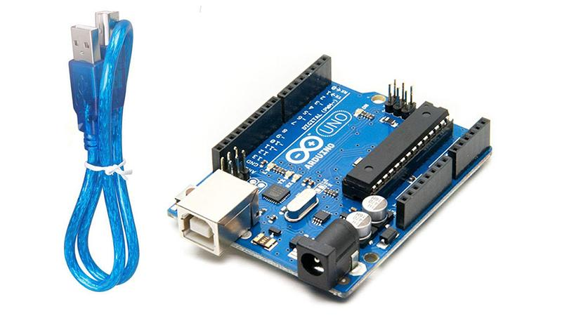

Fig. 3.1.1: Arduino Uno

Technical specifications of Arduino Uno are given below:

* Microcontroller used: ATmega328P
* Required Voltage for Operation: 5 volts
* Voltage Recommendation for Input: 7V to 12V
* Range of Input Voltage: 6V-20V
* Pins for Analog Input: 6 (A0 to A6)
* Pins for digital input and output: 14 (6 Pin for PWM output)
* Required DC Current for input/output Pins: 20 milliampere
* The Arduino has a Static Random-Access Memory which size is 2 kilobytes. It also an electronically erasable programmable read-only memory size of 1 kilobyte.
* CLK /frequency: 16 MHz
* Built-in Light Emitting Diode: 13 number digital pin
* The Arduino length, width, and weight are respectively 68.6 mm, 53.4 mm, and 25g.

**3.1.2 Breadboard**

The breadboard would be a quadrilateral plastic panel that has a slew of small holes drilled into it along its length. Breadboards are also used to develop prototypes of electrical circuits and may be applied for other applications in the future. The breadboard central half contains two columns, separately with 30 connection strips similar to the one on the breadboard that has been pushed out and to the side. These attach whatever that is strapped through from the forward-facing into single of the five holes to form a cohesive unit. Both borders of the breadboard have significantly longer portions of the clip that connect the columns of holes represented by red and blue lines on its exterior. Red lines are intended for 5V and blue line are meant for ground (GND). The interior of a breadboard is constructed of small metal clips, it is possible that the leads will be accommodated by the board.

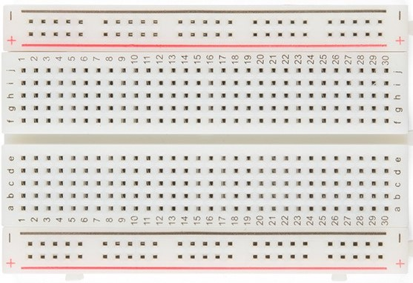

Fig.3.1.2: Breadboard

**3.1.3 Jumper Wire**

Jumper: A wire is a particular stick of metal that is generally cylindrical in shape and it is flexible. Mechanical weights or messages for electricity and telecommunication signal are all carried on wire. Jumper wires are basic cables that include connection pins on both ends, allowing them to link two locations without the requirement for soldering between them. Jumper wires are generally used in conjunction with breadboards and other equipment to create it simple to modify the configuration of a circuit as required. Although jumper wires are available in several colors, the colors themselves have no significance. Although jumper wires are available in several colors, the colors themselves have no significance. Jumper wires are commonly available in three different variants.

1. Male to Male
2. Male to Female
3. Female to Female

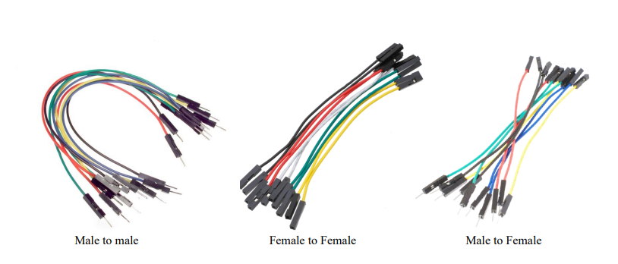Fig.3.1.3: Jumper Wire

A pin protrudes from the male end, allowing it to plug into objects, but female points do not, allowing them to plug into other objects.

**3.1.4 DHT11 Temperature and Humidity Sensor**

The DHT11 is a frequently used temperature and humidity sensor. Both the resistive humidity sensor and the thermistor are used in the construction of the DHT sensors. DHT11 circuit measures the humidity and temperature of the ambient air and then generates a digital signal that is sent to the data port of the microcontroller. Any MCU may be used to read the digital signal, and it is relatively simple to do so. It's pretty easy for using, but it needs precise timing to capture data. Between the two electrodes of the humidity detecting capacitor is a moisture-retaining substrate that acts as a dielectric. When the capacitance value changed, the humidity levels shifted as well. This sensor measures temperature with the use of a thermistor with a negative temperature coefficient, which reduces its resistance with the rise in temperature. With a 2°C and 5% accuracy, the sensor can detect temperatures ranging from 0°C to 50°C and humidity levels ranging from 20% to 80% accordingly. The DHT11 sensor module is supplied with three pins: one for ground (GND), one for power (VCC), and one for data (A Data pin).

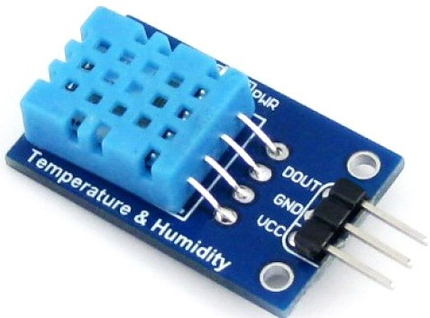

Fig.3.1.4: DHT11 Temperature and Humidity Sensor Module

The DHT11 Temperature and Humidity Sensor has the following characteristics:

* The DHT11 has a 3.5 V to 5.5 V working voltage.
* The DHT11 operates at a current of 0.3mA for measurement and 60uA for standby, respectively.
* The DHT11 has a 16-bit resolution for temperature and relative humidity.
* The size of DHT11 is 15.5mm x 12mm x 5.5mm.
* DHT11 operates at a 1Hz sampling rate.
  + 1. **Node MCU**

Node MCU is an open-source development board for Internet of Things (IoT) applications that works on Lua firmware. It includes hardware based on the ESP-12 module as well as software that runs on the ESP8266 Wi-Fi SoC from Expressive Systems. The ESP8266 Wi-Fi is comprised of many components, including a Central processing unit, Random Access Memory, Wi-Fi, and even a current OS (operating system) and Software Development Kit. The board is comprised of a 32-bit MCU and a Transceiver for Wi-Fi networks, as well as 11 GPIO pins and a corresponding analog input. It implies that we may program it the same way that we would any other Arduino or microcontroller. Additionally, we receive Wi-Fi communication, which allows us to attach to our Wi-Fi system, to connect our smartphone among other things. AT-Command firmware is included within this module that enables it to be utilized with any microcontroller through the COM port. CH340 family of chips is well-known for being a more economical replacement to the CP210x family of chips. The ESP8266 Node MCU is equipped with 30 pins that allow it to communicate with the rest of the world.

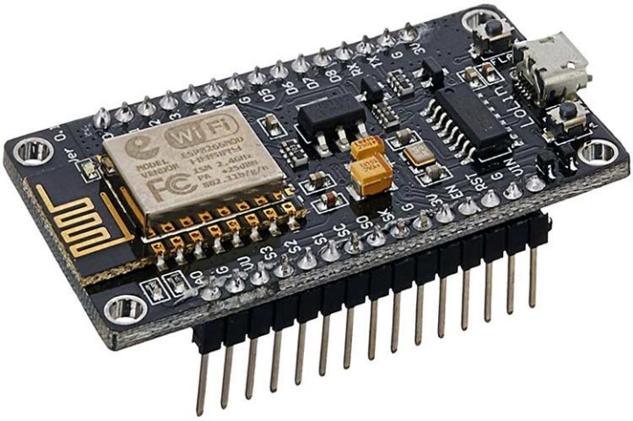

Fig.3.1.5: Node MCU ESP8266 Wi-Fi

Specifications of Node MCU are given below:

* The input voltage range is 7V to 12V
* Node MCU ESP8266 Voltage Required for Operation: 3.3V
* Tensilica 32-bit RISC CPU Xtensa LX106 was used as a microcontroller.
* It has an instruction RAM which size is 64 KB, and also a data RAM of 96 KB.
* 80 MHz is the clock frequency.
* Data transmission interfaces UART and GPIO are supported.
  + 1. **LiPo Battery**

Lipo Battery is an acronym for lithium polymer battery, and it is also referred to as Li-po battery or, more precisely, lithium-ion polymer battery. Instead of a liquid, Lipo is a rechargeable lithium-ion technology battery that uses a polymer electrolyte. Lipo batteries have more incredible particular energy than other kinds of lithium-ion batteries, making them more efficient. It is a more recent form of battery currently found in a wide range of consumer electrical products. Compared to regular LiIon batteries, LiPo batteries have less temperature-free (0'C to 60'C), and draining LiPo cells to ultra-low voltages might be harmful. When a LiPo cell is charged to its trivial voltage of 3.7V, it is known as a lipo cell. A lipo cell = 1 cell = 1S = 3.7V. The battery of lithium polymer may be manufactured with an extremely thin design. The production cost of lithium polymer batteries has now been reduced, and weight is likewise low.

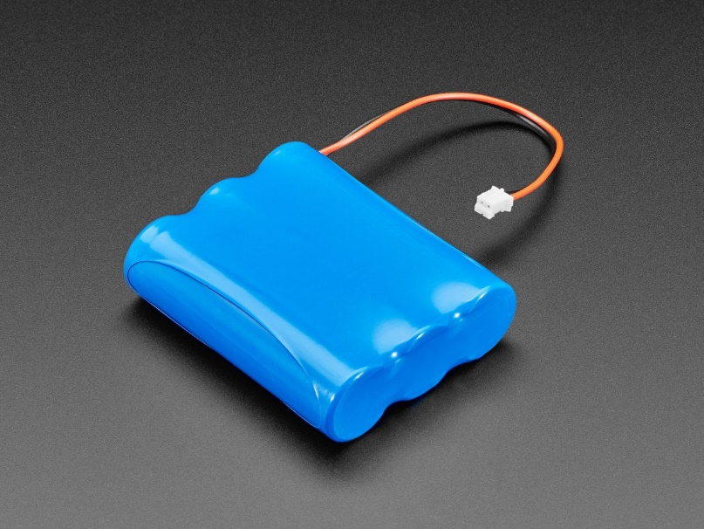

Fig.3.1.6: LiPo Battery

**3.1.7 Ultrasonic or Echo Sensor**

Sensor for ultrasonic waves the HC-SR04 is a distance-measuring sensor. It generates ultrasonic at a frequency of 40kHz that travels through the air, and if an item or obstacle is in its path, it will go closer to the module. You might compute the space by taking into account the travel time and the sound speed. The HC-SR04 ultrasonic sensor, like bats, uses SONAR to determine the size of an object. Even if acoustically, delicate objects like fabric might be difficult to impact upon, the operation is not harmed by sunshine or dark material. It includes an ultrasonic transmitter and receiver module in its entirety.

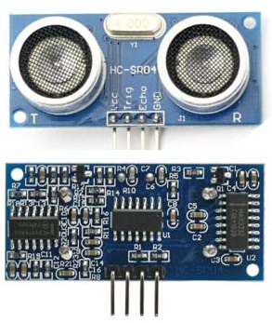

Fig.3.1.7: Ultrasonic Sensor

Ultrasonic Sensor Specifications:

• +5V DC Power Supply

• Working Current: 15mA • Quiescent Current: 2mA

• Effective Angle: 15°

• Range: 2cm – 400 cm/1′′ – 13ft

• Resolution: 0.3 cm

• Measuring Angle: 30 degrees

**3.1.8 L298n Motor Driver**

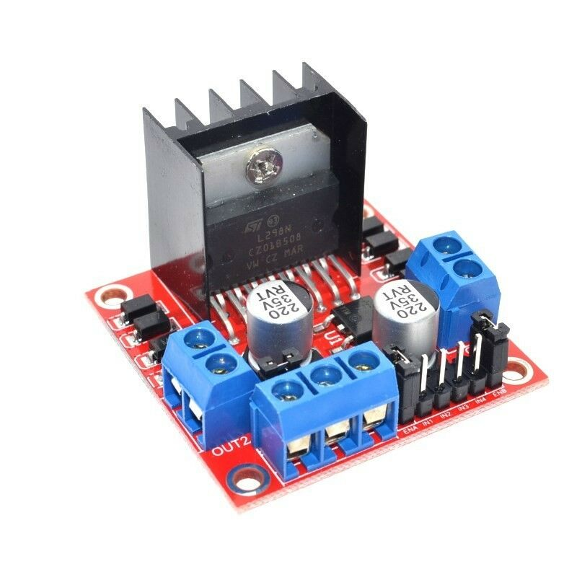 For the DC stepper cars it's attached to, this L298N motor engine results module might be a high-power motor driving force module. An L298 motor control integrated circuit and a 78M05 5V regulator make up this module. The L298N module can control up to four DC cars or four DC cars with route and pace management.

Fig. 3.1.8: L298n Motor Driver

Specifications:

• L298N 2A is the model number of the driver.

• L298N Double H Bridge Driver Chip

• Maximum motor supply voltage: 46V

• Maximum motor supply current: 2A

• Driver Voltage: 5-35V

• Driver Current: 2A

• Logic Voltage: 5V

**3.1.9 Soldering Iron**

Soldering is done with a soldering iron, which is a hand tool. Its ingredients provide heat to melt solder, allowing it to flow between workpieces. Heating is frequently done electrically, with an electric modern-day running via a resistive heating element. Other soldering procedures are used on high-volume manufacturing traces.

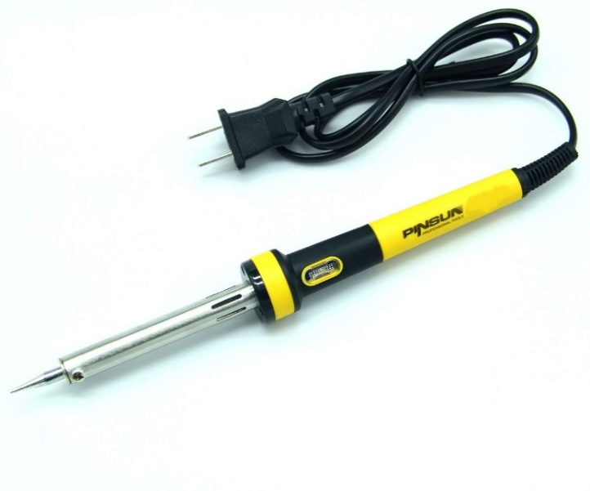

Fig.3.1.9: Soldering Iron

**3.1.10 Screwdriver**

A screwdriver is a tool, manual or powered, used for using screws. A usual easy screwdriver has a take care of and a shaft, finishing in a tip the consumer places into the screw head earlier than turning the take care of.

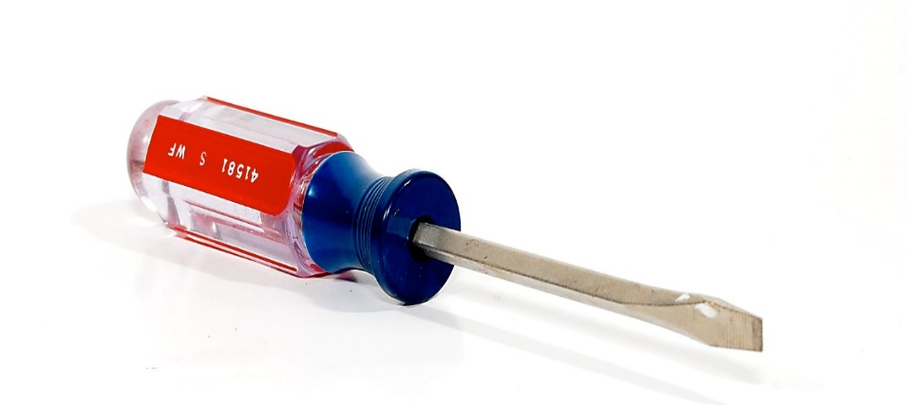

Fig.3.1.10: Screwdriver

**3.1.11 Servo Motor SG-90**

A Micro Servo Motor SG90 is a compact, powerful, and lightweight motor. Servos may spin around 180 degrees as well as 90 degrees in each direction, are smaller, and can be utilized in the same way as regular servos. These servos can be controlled via servo code, hardware, or modules.

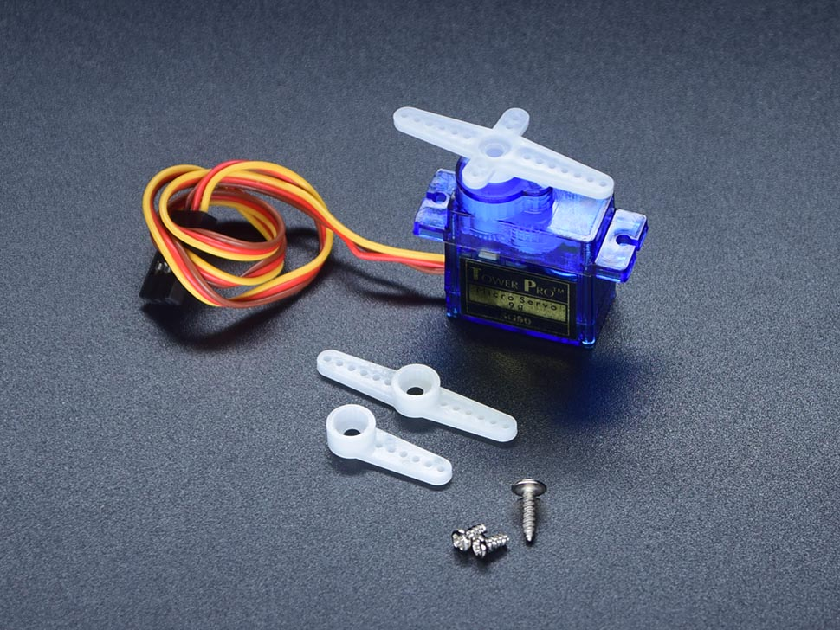

Fig.3.1.11: Servo Motor SG-90

**3.1.12 Arduino MEGA USB**

The most common A to B male to male type supplementary USB string for Arduino is the UNO and MEGA. Connect your Arduino, USB printer, Scanner and further to your computer. Transmits data or program at high pets with error free, high-performance transmission.

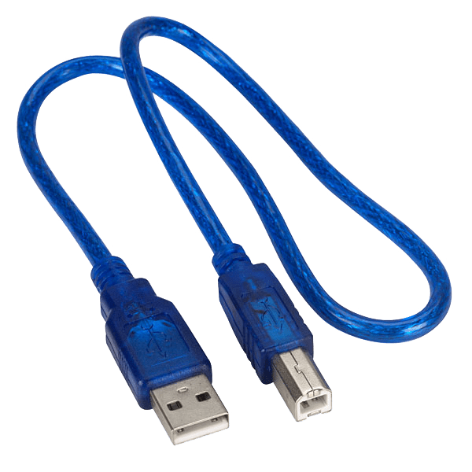

Fig.3.1.12: Arduino MEGA USB

**3.1.13 Two DC motors**

Almost all DC autos contain a few internal systems, each electrical or simulated, that vary the path of modern-day in a component of the motor on a regular basis. Because they can be powered by current direct-present daylights strength distribution infrastructure, DC automobiles were the most widely utilized type of motor. The speed of a DC motor can be controlled in a variety of ways, including employing a changeable supply voltage or converting the power of current in the subject windings. The regular motor can run on direct current, but it's a brushed motor that's ideal for portable energy devices and appliances.

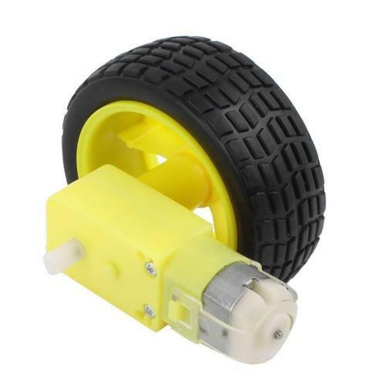

Fig.3.1.13: Two DC Motors

Features & Specifications:

  • Operating Voltage: 4.5V to 9V

• Motor Dimensions: 27.5mm x 20mm x   15mm

• Weight: 17 grams

• Rated Load: 10g*cm

**3.1.14 Two Wheel Robot Car Chassis**

This DIY 2 Wheel Drive Robot Chassis is the suitable mechanical platform in your robotics projects. This package consists of all of the hardware and mechanical additives required to construct your robot, inclusive of motors, wheels, chassis, nut and bolts, etc. Just upload your electronics – Arduino/Raspberry Pi and Motor Driver and you may begin programming your robot. It gives a big area with predrilled holes for mounting sensors and electronics as in keeping with your requirement.

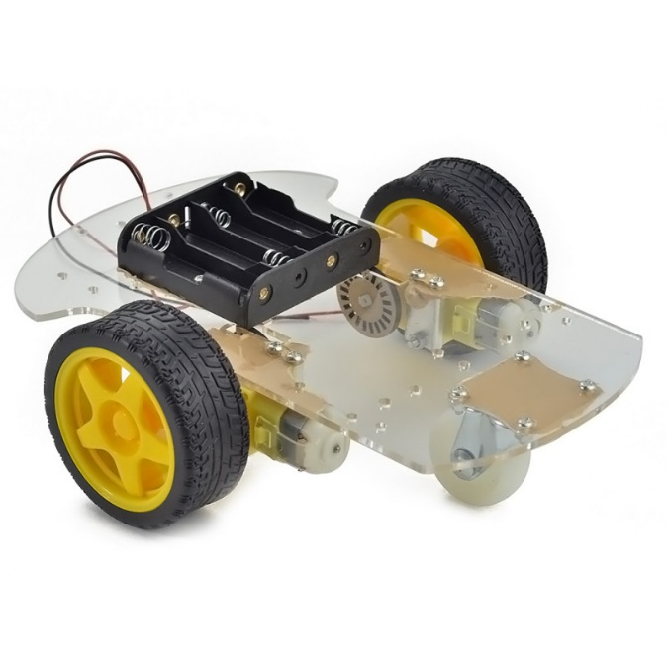

Fig.3.1.14: Two Wheel Robot Car Chassis

Features & Specifications:

* Color: Transparent Water color
* Mechanical shape is easier, it is easier to install.
* This car is the tachometer encoder.
* Can be used for distance measurement, velocity.
* Drive Mode: 2WD
* Load: Much less than identical 2kg Car
* Weight: 285g

**3.1.15 Ultrasonic sonar sensor mounting bracket**

The Ultrasonic Distance Sensor Mounting Bracket is a precisely machined mounting bracket reduce from ¼ in thick excessive-grade aluminum. With clean set up this stand can gracefully connect your Ultrasonic Distance Sensor in your robotic and shield the sensor from maximum collisions.

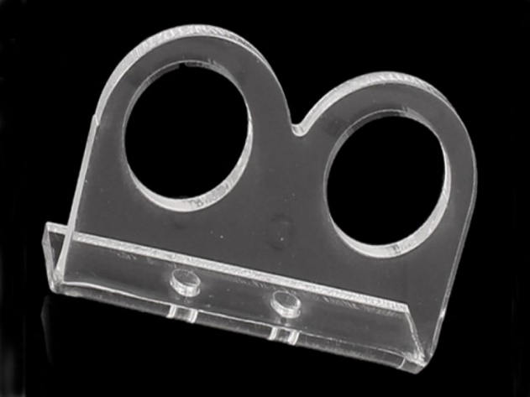

Fig. 3.1.15: Ultrasonic sonar sensor mounting bracket

Features & Specifications:

* Model For: HC-SR04.
* Weight: 8g.
* Thickness ranges from 2.8 to 3.1 mm.
* 16mm inner diameter
* The diameter of the fixing hole is 3.8mm.
* Acrylic sourced from outside.
* Suitable for ultrasonic sensor modules with a steady output.

**3.1.16 Hot Glue Gun**

A hot glue gun is an excellent tool for joining modeling materials together, and even more common materials may be used with it. Strong glue sticks are put into the lower rear of the gun, the cause is squeezed, driving the glue stick forward, and molten glue emerges from the nozzle. The thermoplastics are used to make the adhesive. Plastics that soften and can be reshaped when heated are known as thermoplastics. Some can be used as glues. There are a few exceptions.

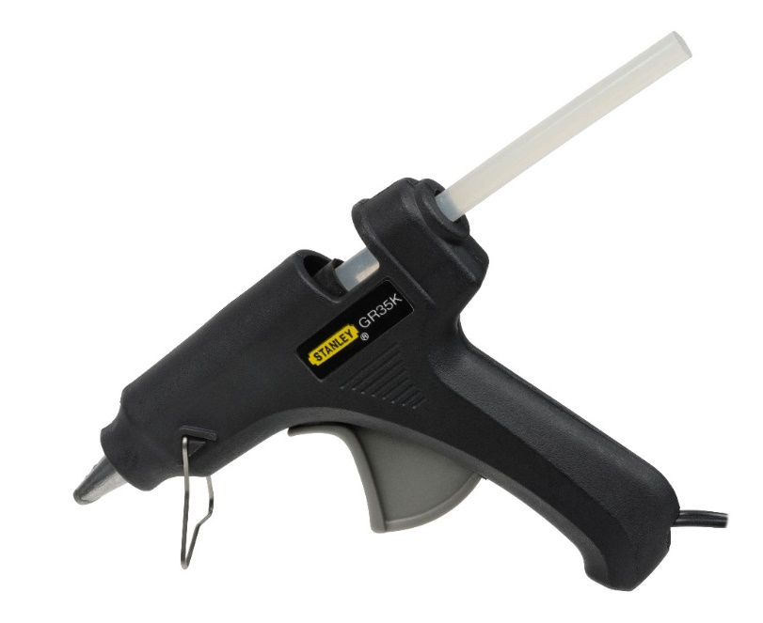

Fig.3.1.16: Hot Glue Gun

Features & Specifications:

* Use of Glue Sticks: Light Usage
* Temperature: High Temp Only (380 ranges F/193 ranges C)
* Tank Capacity: N/A
* Dispensing Rate: 2lb/hour
* Start-Up Time: five minutes
* Power: 60Watt PTC heating system

**3.2 Methodology**

* + 1. **System Architecture**

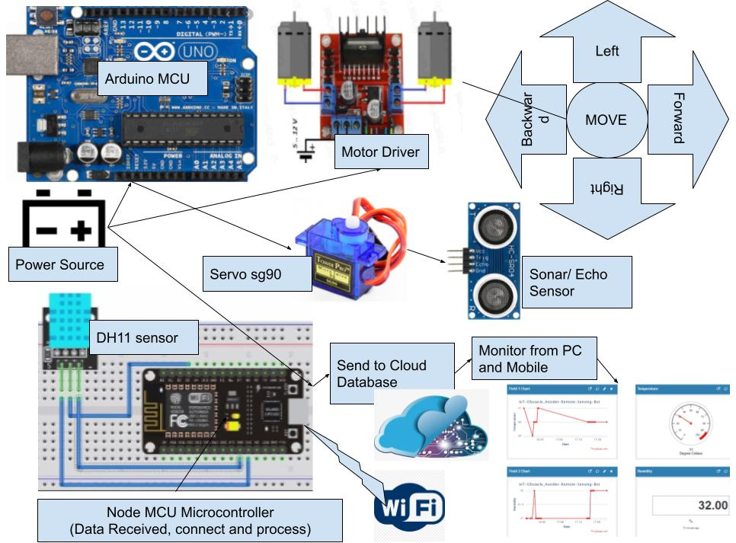

Figure 3.2.1: System Architecture

We can get a clean review of this project with the help of this system diagram. As we are looking to make a remote sensing obstacle avoider, we use a few additives like Arduino UNO, node MCU, sonar sensor, servo motor, and so on. When the Arduino is powered up it'll begin to boost up thyself. When the power is on motor driver started to work smoothly. When the robotic is transferring in the direction of it's going to detect an obstacle via sonar sensor. If there is an obstacle then the robot will stop and start to detect obstacle by using servo motor will help to get cowl more areas via shifting the sonar sensor in various routes. After sensing the obstacle, it'll go to the unfastened course wherein there's no obstacle. It will gather facts by dht11 sensor. We used a NODE MCU to be able to connect via wifi. Node MCU also sends the information to an analytical IoT-based totally platform named "Thingspeak". That platform enables to accumulate, compare and display actual-time information from connected gadgets. For further analysis, if wanted, statistics may be dispatched to Mat Lab. By reading the records any person can easily know the condition what’s going on. For the backup strength delivery, we used a battery.

* + 1. **Flow Chart**

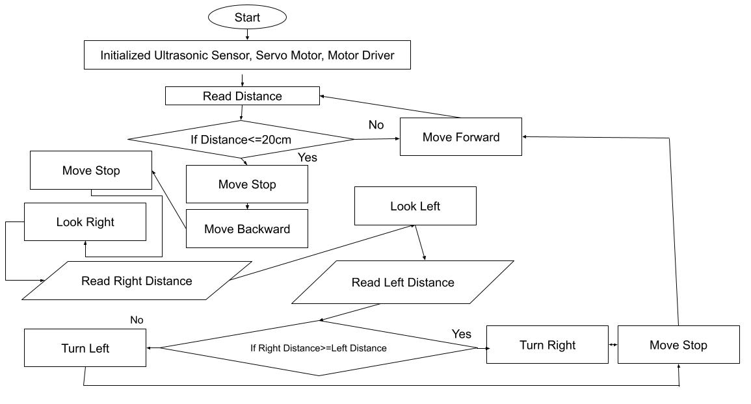

Figure 3.2.2: Flow chart

In the following flowchart, firstly it has to be start. Then in the second step it will initialize the Ultrasonic Sensor, Servo Motor, and Motor Driver. Then it will start to read the distance by Ultrasonic Sensor. If the distance is greater than equal 20 cm than it will move forward and read the distance again. And if the distance is less than equal 20 cm it will stop and move backward and again stop. After that it will look right and read the right distance. Again, it will look left and read the left distance. After reading the left and right distance if the right distance is greater than equal left distance it will turn right and stop. It will move forward and read the distance again. Else the right distance is less than equal then it will turn left and stop. It will move forward and read the distance again.

* + 1. **Algorithm**

The algorithm is underneath it.

Step 1: Start

Step 2: Power the Arduino from the battery.

Step 3: Initializing Ultrasonic sensor, servo motor, and motor driver.

Step 4: Start to examine the impediment distance for avoiding.

Step 5: After detecting the impediment, it will undergo in the direction of free space.

Step 6: Where ever it goes its miles usually sensing the temperature and

humidity.

Step 7: All the information of the sensors may be saved in Node MCU

Step 8: Anyone from a faraway area can see the sensing information at any time

through ‘Thingspeak’.

Step 9: Again, visit step 4 and Arduino follow these little by little.

**CHAPTER 4**

**Results and Output**

**4.1 Project Implementation**

This is the robot’s top view. We can see every component over there. We can see Arduino UNO, Motor Driver, Breadboard, Sonar Sensor etc.

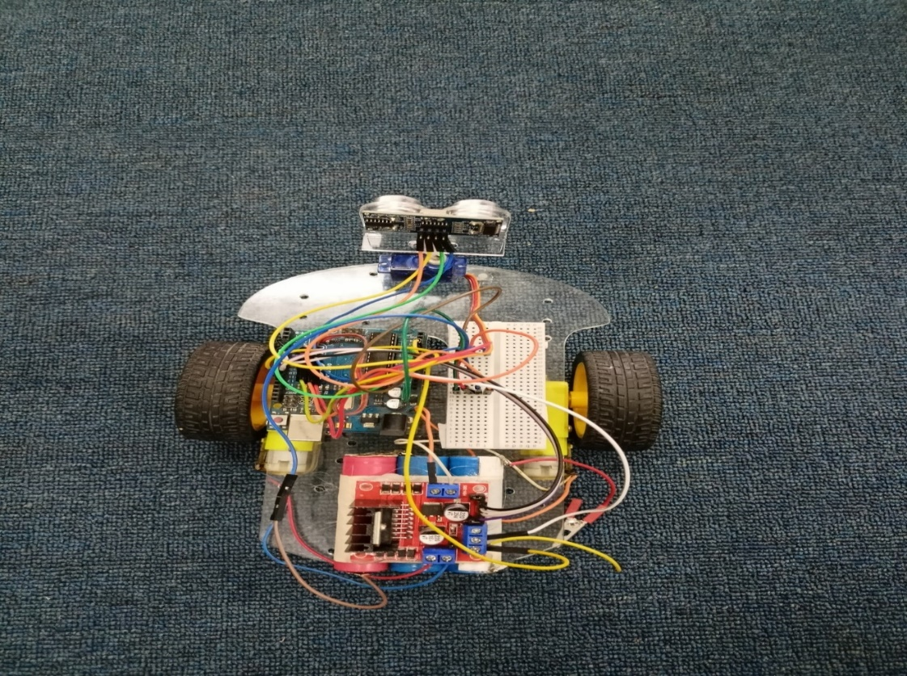

Fig.4.1.1: Project top view

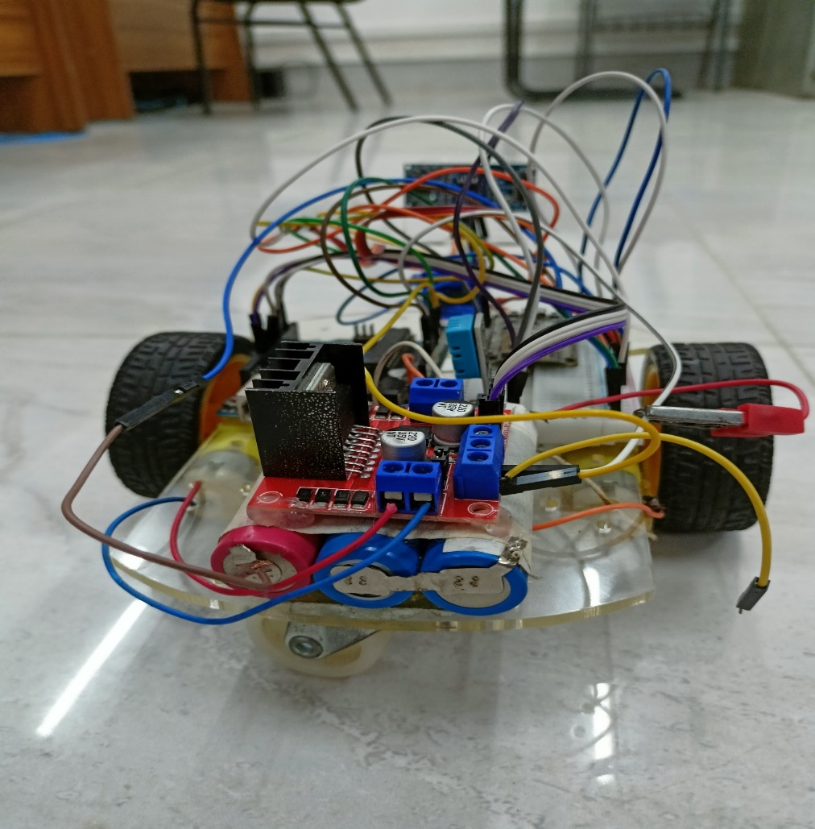

Fig. 4.1.2: Project Rear View

In the Rear side of the chassis a Lipo battery is attached. And on the top of that Motor Driver is attached. We can also see the two-wheeler castor ball chassis with DC motors.

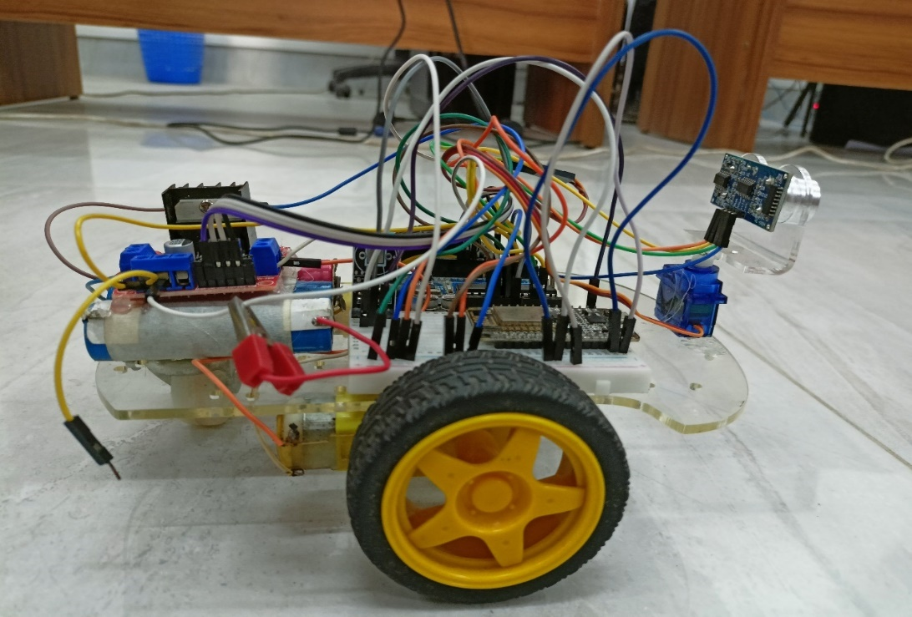

Fig. 4.1.3: Project Side View

We can clearly see the breadboard with the connections of wires. On the top of breadboard there are Temperature and humidity DHT11 sensor and Node MCU. We can also see the total length of the robot.

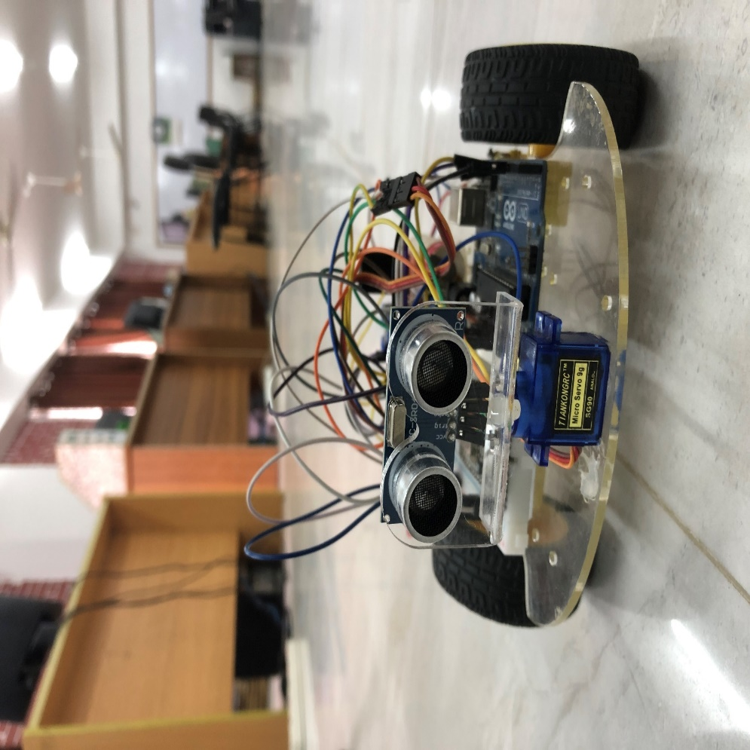

Fig.4.1.4 Project Front View

This is the front view of our robot. Here we can see the eyes of the robot which is basically a sonar sensor. A servo motor is there for helping to find more routes. A little backward there are breadboard and Arduino UNO.

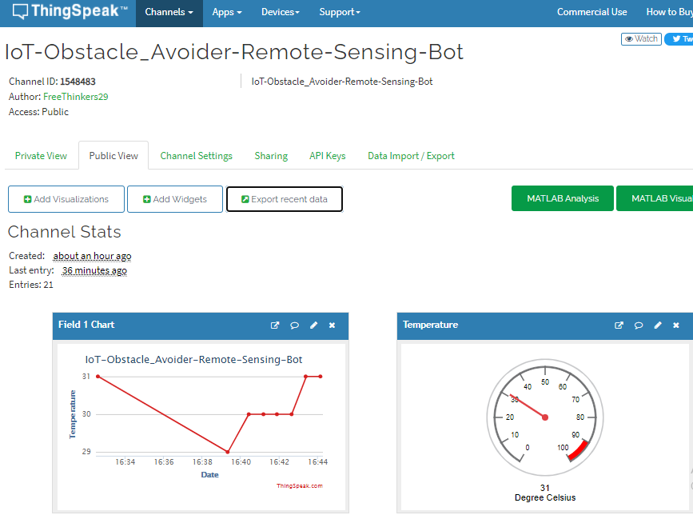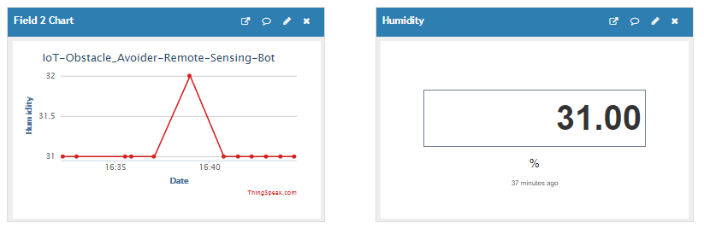

Fig.4.1.5 Cloud Server

Here we can see live data in ThingSpeak that are shown our project. Everyone can see the real time action measurement by using this webserver. We can visit to our channel by this link - <https://thingspeak.com/channels/1548483> .

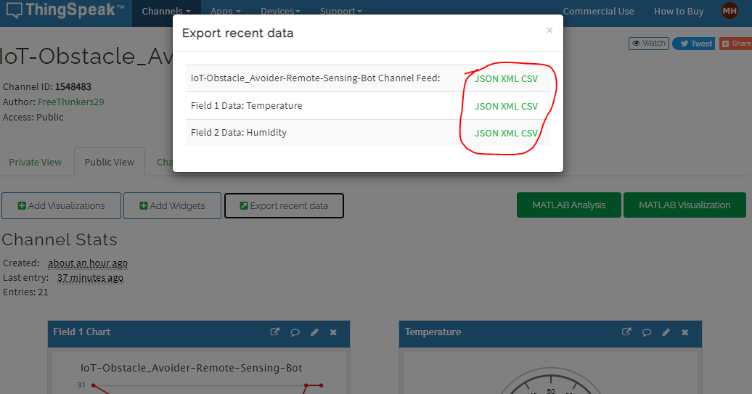

Fig.4.1.6: Cloud Server

Not only we can see the real time data but also in ThingSpeak we can download the CSV, XML or JSON file of our project from the webserver.

**4.2 Result discussion**

Our project output end result is a lot pleased due to it has some a success charge of 95%. In our experiments, we performed a complete of a thousand exams of keeping off the robot. During the testing of this robot, we measured a few different factors. From those exams, we observed out that we carried out a complete of 1000 times of sonar sensors for obstacles sensing off. Also, we carried out the obstacle avoiding command 1000 times. 500 times for temperature sensing of DHT11 sensor, 500 times for humidity sensing of DHT11 sensor, Rotating the motors 1000 times of servo motor, and 500 times of node MCU for receiving the data. And for transmitting the data from Node MCU is 500 times. From those tests, we observed out that our sensors nearly have 95% a hit try. The movement of the servo motor determined is 95%. Working of the Sonar sensor for obstacle sensing determined 93%. Working of the Sonar sensor for obstacle avoiding command determined 94%. Working of temperature sensing by DHT11 found is 98%. Working of humidity sensing by DHT11 found is 98%. Working of receiving the data from Node MCU is 98% and the working of transmitting the data from Node MCU is 98%lastly the working of running wheels functions of Motor Driver is 96% correct. During this time Current and Voltage sizes showed a pleasant price additionally.

|  |  |
| --- | --- |
| Features | Outcome |
| Temperature sensing of DHT11 sensor  Humidity sensing of DHT11 sensor  Obstacle Sensing of Sonar Sensor  Obstacle avoiding command of sonar sensor  Motor rotating of Servo motor  Receiving the data from Node MCU  Transmitting the data from Node MCU  Running wheels functions of Motor Driver | 98%  98%  93%  94%  95%  98%  98%  96% |

Fig. 4.2.1: Result Discussion Table

Fig. 4.2.2: Graphical Representation

**4.3 Features analysis**

In this chapter, we can specifically talk on result evaluation, features and the way we've got succeeded in doing those project

1. Sonar sensor can detect obstacle and avoid it in. Almost 1000 times we used this sensor. For detection and avoiding sonar sensor is used and its outcome is approximately accordingly to 93% & 94% correct.
2. After detecting obstacle by sonar sensor, we can also detect the freeways. And this can only happen when servo motor is working fine. For this we 1000 times plus used this servo motor. After that the outcome comes approximately 95% correct.
3. It can detect the freeways in 3 directions continuously by using servo motor. We almost 1000 times plus used this. And its outcome is approximately 95% right.
4. It also can detect temperature and humidity by DHT11 sensor. We almost used this sensor 500 times plus each. And its outcome is approximately accordingly 98% & 98% correct.
5. It can receive, transmit and store the data in cloud by using Node MCU. We use this almost 200 times plus and its outcome is accordingly 98%, 98% and 98% correct.
6. The working of Motor Driver’s running functions such as forward left motor forward, left motor backward, right motor forward, right motor backward. This wheel works totally fine. And the accuracy of the is 96%.

**4.4. Limitations**

1. It can't produce tons power in cloudy and foggy weather.
2. We need a power deliver to boost up both the microcontrollers.
3. In wet days, there is a danger of unfavorable the components if there is no water-resistant case.

**CHAPTER 5**

**Future Plans and Conclusions**

**5.1 Future Plans**

This paper is all approximately Obstacle Avoidance Robot the usage of Arduino which avoids barriers which it encounters. It also senses data and send it to the server. The most probable future plans are underneath it.

1. In the future, this project could be improved by connecting a Bluetooth module.
2. We will add some camera for more accurate detection.
3. We will add some more sensors that will collect different types data.
4. It will be more efficient in detection and data analysis.

**5.2 Conclusions**

This challenge developed an obstacle-avoiding robot to stumble on and keep away from

barriers in its route. Also, it is able to stumble on extraordinary subjects through using the usage of sensors. The robot is based on the Arduino platform for data processing, and its software program application counterpart assisted in communicating with the robot to supply movement parameters. An ultrasonic distance sensor with the assistance of a servo motor was employed to identify impediments, which created a mile-wide detection challenge. The robotic is completely self-contained, and it does not require any human assistance beyond the initial code loading. It moved while warding off all impediments with great precision when placed in an unfamiliar environment with hazards. These elements majorly affected the sensors. These factors have a significant impact on the sensors. The robotics’ precision is determined by the sensors employed. As a result, the sensor's characteristics and accuracy described the precision of my robot.**Reference:**

1. Fraga-Lamas, P., Ramos, L., Mondéjar-Guerra, V. and Fernández-Caramés, T.M., 2019. A review on IoT deep learning UAV systems for autonomous obstacle detection and collision avoidance. *Remote Sensing*, *11*(18), p.2144.
2. 2.. Sawant, M., Pagar, R., Zutshi, D. and Sadhukhan, S., 2021. IoT-based fire detection and control robot. In *Advances in Machine Learning and Computational Intelligence* (pp. 567-577). Springer, Singapore.
3. Akhund, T.M.N.U., Sagar, I.A. and Sarker, M.M., Remote Temperature Sensing Line Following Robot with Bluetooth Data Sending Capability.
4. Amir attar, aadilansari, abhishek desai, shahid khan, dip ashrisonawale line follower and obstacle avoidance bot using arduino International Journal of Advanced Computational Engineering and Networking, vol. 2, pp. 740-741, August 1987.
5. Aniket D. Adhvaryu et al Obstacle-avoiding robot with IR and PIR motionSensors IOP Conference Series: Materials Science and Engineering, vol. A247, pp. 529-551, April 2005.
6. Vaghela Ankit1, Patel Jigar2, Vaghela Savan3 Obstacle Aoidance Robotic Vehicle Using Ultrasonic Sensor, Android and Bluetooth for Obstacle Detection International Research Journal of Engineering and Technology (IRJET), vol. A247, pp. 29-32, 2005.
7. Paul Kinsky,Quan Zhou Obstacle Avoidance Robot Worcester polytechnic institute.
8. FaizaTabassum, SusmitaLopa, Muhammad MasudTarek& Dr. Bilkis Jamal Ferdosi obstacle avoidance carGlobal Journal of Researches in Engineering: HRobotics & Nano-Tech.
9. Ekeh Godwin, E., Idris, A.Y. and Julian, A.O., 2021. Obstacle Avoidance and Navigation Robotic Vehicle using Proximity and Ultrasonic Sensor, Arduino Controller.
10. Zhao, J., Gao, J., Zhao, F. and Liu, Y., 2017. A remote-sensing search-and-rescue robot system for the underground coal mine environment. Sensors, *17*(10), p.2426.
11. Yılmaz, E. and Tarıyan Özyer, S., 2019. Remote and Autonomous Controlled Robotic Car based on Arduino with Real Time Obstacle Detection and Avoidance.
12. Zavlangas, P.G. and Tzafestas, S.G., 2000. Industrial robot navigation and obstacle avoidance employing fuzzy logic. *Journal of Intelligent and robotic Systems*, *27*(1), pp.85-97.
13. Lazarowska, A., 2021. Review of Collision Avoidance and Path Planning Methods for Ships Utilizing Radar Remote Sensing. *Remote Sensing*, *13*(16), p.3265.
14. Saeed, M.S. and Alim, N., 2019, January. Design and implementation of a dual mode autonomous gas leakage detecting robot. In *2019 International Conference on Robotics, Electrical and Signal Processing Techniques (ICREST)* (pp. 79-84). IEEE.
15. Wu, Q., Shen, X., Jin, Y., Chen, Z., Li, S., Khan, A.H. and Chen, D., 2019. Intelligent beetle antennae search for UAV sensing and avoidance of obstacles. *Sensors*, *19*(8), p.1758.
16. Mohamed, A., Ren, J., El-Gindy, M., Lang, H. and Ouda, A.N., 2018. Literature survey for autonomous vehicles: sensor fusion, computer vision, system identification and fault tolerance. *International Journal of Automation and Control*, *12*(4), pp.555-581.
17. Zhang, W., Wei, S., Teng, Y., Zhang, J., Wang, X. and Yan, Z., 2017. Dynamic obstacle avoidance for unmanned underwater vehicles based on an improved velocity obstacle method. *Sensors*, *17*(12), p.2742.
18. Al-Kaff, A., García, F., Martín, D., De La Escalera, A. and Armingol, J.M., 2017. Obstacle detection and avoidance system based on monocular camera and size expansion algorithm for UAVs. *Sensors*, *17*(5), p.1061.
19. Sharma, P. and Kamthania, D., 2019, March. Intelligent object detection and avoidance system. In *International Conference on Transforming IDEAS (Inter-Disciplinary Exchanges, Analysis, and Search) into Viable Solutions* (pp. 342-351).
20. Zhang, Y. and Wang, J., 2004. Obstacle avoidance for kinematically redundant manipulators using a dual neural network. *IEEE Transactions on Systems, Man, and Cybernetics, Part B (Cybernetics)*, *34*(1), pp.752-759.